Think | Make | Improve
- Brainstorming  - Thinking it out  - Predicting  - Gathering materials  - Identifying expertise  - Deciding who to work with  - Setting goals  - Sketching  - Outlining  - Flowcharting  - Researching  - Planning | - Play  - Build  - Tinker  - Create  - Program  - Experiment  - Construct  - Deconstruct  - Test strategies/material  - Observe others  - Borrow code  - Share code  - Document their process  - Look for design vulnerabilities  - Ask questions  - Repair their creation | - Conduct research  - Talk it out  - Discuss with peers  - Look at from a different perspective  - Change one variable at a time  - Think about ways in which you solved similar problems in the past  - Play with it  - Find a similar project you might analyze or deconstruct  - Ask an expert  - Be cool  - Get some fresh air  - Sleep on it
Gravity Cruiser Lesson
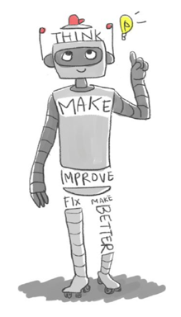

Martinez, Sylvia Libow, and Gary Stager.Invent to learn: making, tinkering, and engineering in the classroom. Torrance, Calif.: Constructing Modern Knowledge Press, 2013. Print.
Introduce the Problem
- Introduce Letter from Earth Toy Designs
Team-building
- Place students in teams of 3
- Student contract
- Team name and individual contributions
Empathize
- What does this company need?
- What do children need?
- What must your design provide?
We must build a toy that:
- ?????
- ?????
- ?????

Think - Build Background Knowledge

Force and Motion / Simple Machine Content
- Review of text material identifying vocabulary (what I know, need to know)
- KWL chart with entire class (Guiding and adding questions as necessary)
- Categorize questions and give to groups to research with a jigsaw format
- Share research information within groups
- Class discussion
- Quiz

Imagine and draw different solutions.
Choose one solution to begin.

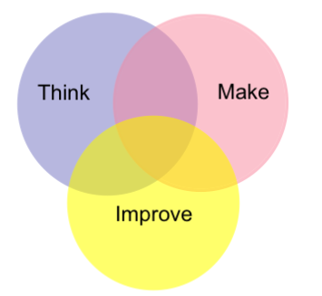
Build the Chassis

Think – Research, Imagine, Sketch, Plan
Make – Build the prototype and test
Improve – Change one variable at a time,
discuss with peers, consult an expert

Science Practices Focus – Controlling
variables

Reflect
How is the science content (Force and Motion / Simple Machines) related to our how our chassis works?
- Class discussion
- Personal reflection

Finish Building the Gravity Car
Think
Background Knowledge - Gravity
- What do we know about
gravity and what do we need to
know to use these materials to
make gravity run this car?
- Research need to know
- questions
- Mini Lesson - Galileo’s experiments – design your own experiment to support the work of Galileo
- How will this knowledge of gravity apply to designing our gravity car?
- Imagine, Sketch, Plan
Make
- Construct a prototype and test
Improve
- Change one variable at a time, discuss with peers, consult an expert, research
- Use the computer simulation, as they need it, to question parts of their design. How might the simulation inform decision-making.?

Final Car Run
Collect and analyze data.
- How do we determine speed?
- How is speed represented on a graph?

Reflection
List one mistake your team made in your design? How did you go about correcting this mistake? What did you learn from making and correcting this mistake?
What did you learn from watching the other cars?
What did you learn about working together in a team?
What did you learn about force and motion that you might use in your life?
…..Simple machines?

Final Assessment
Test
- Science content
- Making connections between the content and the car design

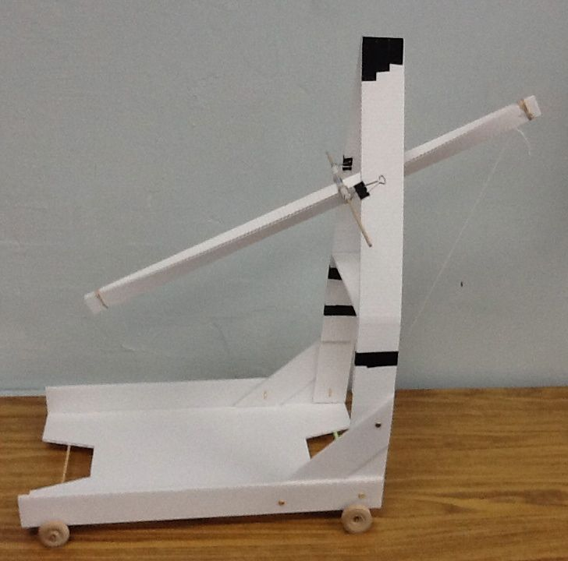
Gravity Cruiser --- Test It
Data Collection

Title: _________________________________________________

Trial | Distance (m) | Time (sec) | Speed (m/sec)
One

Two

Three

Average

Graph of distance vs time for each trial and average runs

Distance (m)

Time (sec)

What is the relationship between speed and the line on your graph?

